Accident Prevention / Safety Plan

Prepared for:
General Information

Prepared by:
CAPEX Construction
1146 North 1190 East
American Fork, Utah 84003
Phone: (719) 640-2049

Dated

Contents
1. Signature Sheet 5
1.1. Plan Preparer (Site Safety & Health Officer) 5
1.2. Corporate Sponsor & Plan Concurrence (COO) 5
2. Background Information 6
2.1. Contractor 6
2.2. Project Number 6
2.3. Project Name & Location 6
2.4. Project Description 6
2.4.1. Overview 6
2.4.2. Scope of Work 6
2.4.3. Site Map 7
2.4.4. Contractor’s Accident Experience 7
2.5. Listing of Phases of Work Activities Requiring AHAs 7
3. Statement of Safety and Health Policy 8
4. Responsibilities and Lines of Authority 9
4.1. Roles 9
4.1.1. Contractor – CAPEX 9
4.1.2. Site Safety and Health Officer (SSHO) – Miguel Cisneros 9
4.1.3. Project Manager – Brian Madsen 9
4.1.4. Field Team Members 10
4.2. Lines of Authority for Project Safety 10
5. Subcontractors and Suppliers 10
5.1. Identification of Subcontractors and Suppliers 10
5.2. Means for Coordinating Subcontractors and Suppliers 10
5.3. Safety Responsibilities of Subcontractors and Suppliers 10
6. Training 11
6.1. Indoctrination 11
6.2. List of Mandatory Trainings 11
6.3. Emergency Response Training 11
6.4. Supervisory and Employee Safety Meetings 12
7. Safety and Health Inspections 12
7.1. Who, When, How? 12
7.2. Certifications Required for Inspections 13
8. Safety and Health Expectations and Compliance 13
8.1. Safety Program Goals and Objectives 13
8.2. Company Incentive Programs 13
8.3. Policies and Procedures Regarding Noncompliance 13
8.4. Procedures for Holding Supervisors Accountable 14
9. Accident Reporting 15
9.1. Exposure Data 15
9.2. Accident Investigations & Reports 15
9.3. Immediate Notification of Major Accidents 15
10. Medical Support 15
10.1. Address and Directions to the Nearest Hospital 15
10.2. Emergency Medical Service Phone Number 16
10.3. Onsite Medical Support 16
10.4. Onsite Contractor Personnel Trained in First Aid & CPR 16
11. PPEs 16
11.1. PPE Required Onsite 16
12. Plans (Programs, Procedures) 17
12.1. Layout Plans 17
12.2. Emergency Response Plans 17
12.2.1. Primary Meeting Point 17
12.2.2. Emergency Events 17
12.2.4 Evacuation 17
12.2.5 Personnel Injury 18
12.2.6 Decontamination and Medical Treatment 18
12.2.7 Emergency Information 18
12.2.8 Emergency Recognition and Prevention 18
12.2.9 Spill Plans 19
12.2.10 Fire Fighting Plan 19
12.2.11 Posting of Emergency Telephone Numbers 20
12.3 Hazard Communication Program 20
12.3.4 General Information 20
12.3.5 Container Labeling 20
12.3.6 Material Safety Data Sheets (MSDS) 20
12.3.7 Hazardous Non-Routine Tasks 21
12.3.8 Lists of Hazardous Materials 21
12.4 Respiratory Protection Plan 21
12.5 Health Hazard Control Program 21
12.6 Asbestos Abatement Plan 21
12.7 Confined Space 21
12.8 Critical Lift Procedures 21
12.9 Contingency Plan for Severe Weather 21
12.10 Access and Haul Road Plan 22
12.11 Formwork and Shoring Erection and Removal Plans 22
12.12 Plan for Prevention of Alcohol and Drug Abuse 22
12.13 Fall Protection Plan 23
12.14 Steel Erection Plan 23
12.24.1 Steel Erection 23
12.24.2 Written Notifications 23
12.24.3 Site Layout 24
12.24.4 Deficiencies 24
12.24.5 Structural Steel Assembly 24
12.24.6 Metal Decking 24
12.25 Site Sanitation Plan 24
12.26 Fire Prevention Plan 25
12.27 Storage of Flammable Materials 25
12.28 Materials Handling and Storage 25
12.29 Guarding of Portable Power Tools 26
12.30 Proper Grounding and Insulation of Electrical Devices 26
13 Site-Specific Hazards and Controls (AHA’s) 27
14 Sample Forms 28
15 Project Personnel Resumes & Qualifications 37

Signature Sheet

Plan Preparer (Site Safety & Health Officer)

Justin Lee,
Phone: (719) 640-2049 Email: justin@capexbuilt.com

____________________________________________________________

Corporate Sponsor & Plan Concurrence (COO)

Brian Madsen, COO
Phone: (702) 755-6801 Email: brian@capexbuilt.com

____________________________________________________________

Background Information

Contractor
CAPEX Construction
1146 North 1190 East
American Fork, Ut 84003

Project Number
To be determined

Project Name & Location
To be determined

Project Description

Overview
Written for each project

Scope of Work
Provide all supervision. labor, equipment, materials, supplies, and transportation necessary to install temporary barriers, demolish and repair decayed and weathered structures (new construction), and prepare and paint required surfaces.

Paint color is subject to change. Paint must not be ordered until proposal is accepted, and a pre-construction meeting has been convened with SAVAHCS Interior Design. Type of paint described in the attached A/E narrative will not change.

Contractor shall conduct a lead survey of the old paint on all buildings listed. If lead is found, Contractor will discuss abatement methods and changes in scope with the Contracting Officer Representative (COR) and Contracting Officer (CO).

Total construction period duration includes all pre-construction activity and postconstruction testing, third-party inspections, and phased building turn-over to the Government. Contractor shall submit a comprehensive schedule of work in compliance with 01 32 16.15 PROJECT SCHEDULES (SMALL PROJECTS DESIGN/BID/BUILD). Each Building shall be accepted by SAVAHCS Engineering COR prior to beginning work on the next Building.

Site Map
Upon Request

Contractor’s Accident Experience
Zero Incident Safety Performance – We have never experienced an OSHA recordable incident.

Listing of Phases of Work Activities Requiring AHAs
The following work activities have been identified for this general project scope:
- Stucco Repair
- Woodwork Repair
- Caulking and Sealing
- Painting

At a minimum, each work activity may require the completion of an Activity Hazard Analysis (AHA) and may, if required, be completed by the subcontractor and submitted to CAPEX for approval prior to starting the activity. The approved AHAs will remain available for the duration of the project, and they will be incorporated into the weekly training during the phases of construction.

Statement of Safety and Health Policy
We are committed to conduct our operations in a manner that will promote the protection of the general health, safety, and welfare of its employees, the public, and the environment. To protect the safety and health of our employees and minimize our environmental footprint, we are committed to the following:

Conducting operations in compliance with all applicable health and safety laws, regulations, and standards; Establish appropriate environmental health and safety standard operating procedures to protect employees, subcontractors, the general public and the environment from physical hazards at all project locations; Establish effective management systems to promote safety awareness; Provide employees with the necessary training to ensure full compliance with all applicable environmental, health and safety issues and concerns.

This Accident Prevention Plan was prepared in accordance with guidelines set forth in the CAPEX Health and Safety Standard Operating Procedures (SOPs), the applicable OSHA Regulations and the U.S. Army Corps of Engineers Safety Manual EM385-1-1 (current edition). The provisions of the Accident Prevention Plan apply to CAPEX personnel and ALL subcontractor activities associated with this project. The health and safety guidelines and requirements presented herein are based on a review of available information and an evaluation of potential hazards. This plan describes the health and safety procedures required for activities to minimize the potential for accidents to field personnel. Should circumstances during fieldwork be extraordinarily different than anticipated, activities shall be temporarily stopped, so that potential hazards can be evaluated, and appropriate health and safety precautions implemented.

CAPEX personnel will implement the provisions of this Accident Prevention Plan. All CAPEX employees and our subcontractors are expected to be familiar with and comply with the minimum requirements set forth in this Accident Prevention Plan.

On each job the site safety and health supervisor (SSHS) will be responsible for implementing the safety program. All visitors, employees and subcontractors shall adhere to the rules, regulations, and other provisions of our Safety Program.

A comprehensive safety and health program shall be maintained with the objective of reducing the number of accidents to an absolute minimum; zero recordable and zero lost time incidents. To be successful, such a program must embody the proper attributes towards accident prevention on the parts of both supervisors and employees.

Responsibilities and Lines of Authority

Roles

Contractor – CAPEX
CAPEX is the contractor responsible for conducting work and implementing the SSHP. We will conduct weekly ‘tailgate’ safety briefings for all personnel working on or entering the site.

Site Safety and Health Officer (SSHO) – Justin Lee
The SSHO is responsible for implementing and overseeing the SSHP. The SSHO is responsible for personnel on the site, maintaining proper medical surveillance, providing hazard communication information, training employees in safe operating procedures, emergency response, reviewing accident reports, reviewing inspection results, and advising the health and safety manager (HSM) and project manager on matters concerning the health and safety of employees or the public. The SSHS will be identified in the Sampling and Analysis Plan (SAP). The SSHS may be required to perform various types of area or personnel monitoring to verify worker exposure and ensure the proper selection of personal protective equipment (PPE). The SSHO should be consulted before any changes in the recommended procedures or levels of protective clothing are made.

Brian Madsen is also our competent person and has received his OSHA 30 training course.

Project Manager – Brian Madsen
The project manager is Brian Madsen. Mr. Madsen has primary responsibility for fulfillment of contract terms and oversight of operations to verify that all legal and safety requirements are met. Mr. Madsen also has the responsibility to keep the project on schedule and within budget.

He has the primary responsibility to satisfy the technical and administrative requirements of the project and will provide direction and oversight to the SSHO. The project manager will be responsible for communicating progress and any problems to the building owner. The project manager is responsible for procuring and providing the proper safety equipment at the site.

Field Team Members
The field team members will be responsible for reading and understanding the SSHP and following the directives of the SSHO, QCM, and the PM. The field team members will be responsible for performing all work according to the procedures outlined in the SSHP and to notify the SSHO, QCM, and the PM of any conditions that may pose a threat to the safety and health of the employees and the community.

Lines of Authority for Project Safety
Should an emergency develop while construction personnel are onsite, lines of authority have been established for supervising the situation. The Site Emergency Contact (EC) for this project is the SSHO, Justin Lee. Justin has completed the CPR, First Aid and 30-Hour OSHA Health and Safety Certification Training. The SSHO will be responsible to provide reporting of accidents and will be reported as soon as possible but no more than 24 hours afterwards to the COR. The SSHO and Corporate Safety Manager will thoroughly investigate the accident and submit the findings of the investigation along with appropriate corrective actions to the COR in the prescribed format as soon as possible and/or within 24 hours. Corrective actions will be implemented as soon as reasonably possible.

Subcontractors and Suppliers

Identification of Subcontractors and Suppliers
Subcontractors and Suppliers on this project include, but are not limited to the following:

- Wiese Painting Contractors

Means for Coordinating Subcontractors and Suppliers
The Project Superintendent will control and coordinate with subcontractors and supplies on phases of work, delivery of materials etc. This will be accomplished through weekly safety and coordination meetings.

Safety Responsibilities of Subcontractors and Suppliers
All subcontractors and suppliers will be responsible for meeting the requirements of this Accident Prevention Plan (APP) as well as all applicable OSHA and US Corps of Engineers Manual EM385-1-1 standards.
Subcontractors will be responsible for following this plan only in its entirety. Subcontractor personnel must attend CAPEX weekly safety meeting. Additionally, the subcontractors must provide a copy of their weekly safety meetings to CAPEX SSHO and/or Project Manager.

A subcontractor found to be in violation of any safety policy or regulation will first be given a verbal warning the second warning will be written; and further non-compliance may result in the cited employees or supervisors being removed from the job site and/or termination of the subcontract.

Training
OSHA regulations included in 29 CFR part 1926.21 requires all employees receive safety training for work they are required to perform. The CAPEX SSHO will conduct such training during their weekly safety meetings. All site employees are required to attend their employer’s weekly safety meetings.

Attendance to CAPEX safety meetings does not alleviate the subcontractor’s own responsibility to train subcontractor personnel.

Documentation of weekly safety meetings will include signatures of all attendees and a general overview of all topics discussed. Documentation of all CAPEX safety meetings will be retained on-site until project completion. Training for unique issues and specific problems will be conducted when applicable.

Indoctrination
Before any CAPEX Employee of Subcontractor begins work on site, they will be instructed on the specific requirements of this Accident Prevention Plan, which will include all specific issues addressed in this plan. New employees shall be instructed on all areas of the job specific accident prevention plan.

List of Mandatory Trainings
Mandatory training on this project shall consist of the elements required for each individual to complete their specific task of work. Recurring training will also be covered in the AHA.
CPR/First Aid qualifications shall be ALWAYS maintained by at least 2 key personnel onsite. Also, all site personnel are required to be trained and have an OSHA-10 Card. We will always have a competent person and an individual that has completed and received their OSHA-30 training.

Although the same person may be both the Competent Person and the OSHA-30 Certified individual CAPEX will always fulfill this requirement.

Emergency Response Training
CAPEX intentions are to provide a safe working environment to all its personnel. However, if an injury should occur, proper accident reporting and investigative procedures must be activated. The following is the general policy of accident reporting and investigative procedures of CAPEX:
- Employees shall immediately report all injuries, sustained while on duty, immediately to the field site manager.
- The field site manager shall be responsible for seeing that injured employees receive immediate medical attention, and the details of the incident are reported.

Immediately following an injury, the field site manager shall:
- Arrange for immediate medical attention and proper transportation to the place of treatment.
- Completely fill out an incident report form. The incident report form must be submitted within 24 hours.
- Start the investigative process to prevent recurrence of the same accident.
- When a field site manager is aware of lost time (disabling injury) accident, he/she shall immediately report the injury to the CAPEX project manager.

In the event of death or very serious injury, the President shall inform OSHA. The project manager shall be responsible for keeping management informed on the status of all accidents, the maintenance of accident report records and for administration of industrial injury reports to comply with the law.

Supervisory and Employee Safety Meetings
CAPEX field personnel will hold a brief ‘tailgate’ safety meeting to discuss possible site hazards each morning prior to commencing work. Weekly safety meetings will be documented on the Safety Meeting Log Sheet.

Safety and Health Inspections

Who, When, How?
The following individuals are responsible for conducting safety inspections:

Justin Lee: SSHO

Justin has completed 30-Hour OSHA Safety Training. See certs at the end of this APP

Safety Inspections will be performed continuously and ongoing throughout the day. Any safety violations will be corrected immediately. The SSHO and Project Manager have full authority to stop work should a safety concern present itself which warrants stopping work until the issue is resolved. Follow-up on corrective action will take place throughout the day until the deficiency has been resolved.

Construction Supervisor Safety Checklist (sample) can be found in Section 14.

*** For any dangers that are serious and/or immediately dangerous to life or health, work shall be stopped until corrective actions have been made. Every employee onsite has this obligation to protect not only themselves but the other people working around them.

Certifications Required for Inspections
Justin Lee has completed 30-Hour OSHA Safety Training. See certificates at the end of this APP.

Safety and Health Expectations and Compliance

Safety Program Goals and Objectives
That we will complete projects without lost time or injury in accordance with OSHA, State, and Federal Safety regulations.

Company Incentive Programs
N/A

Policies and Procedures Regarding Noncompliance
CAPEX is committed to conducting our operations in a safe manner. To ensure compliance with company policies on all CAPEX projects, a progressive disciplinary procedure is required. Personnel who do not follow safety regulations and CAPEX polices regarding safety will not be allowed to continue working for CAPEX, either as CAPEX employees or as subcontractors. The progressive safety disciplinary procedure will be as follows:

First offense:
Required to stop work immediately and /or removal from the job site until the safety violation has been addressed and corrected. Immediate correction of safety violation. Written personal safety citation to person involved. Person will be required to meet conditions (set by SSHO) prior to being allowed back on site such as retraining, personal commitment to safety, etc. Copy of personal citation is given to direct supervisor of the person who received the citation. Safety violators can only be allowed back on-site with the approval of the SSHO and PM. Safety citations are reviewed weekly with the PM, his/her direct supervisor (General Manger, Division Manager or Vice President) and monthly with the Vice Presidents and President.

Second offense:
Same as the first offense. Suspension from all CAPEX job sites for a specified period of time (depending on the severity of the offense). Direct supervisor of the person receiving a personal citation will be given a supervisory citation. In addition, supervisory citations may be given to all personnel in any supervisory role to this person (PM, SSO, site superintendent, division manager, general manager, etc.).

Third offense:
Same as the first offense. Permanent removal from all CAPEX project sites. Direct supervisor of the person receiving a personal citation will be given a supervisory citation. In addition, supervisory citations may be given to all personnel in any supervisory role to this person (PM, SSHO, site superintendent, division manager, general manager, etc.). Suspension or Termination.
This progressive disciplinary procedure may be changed due to the severity of the offense. Severe offenses may require immediate termination. This determination will be made by the person giving the citation in conjunction with the Project Manager, General Manager, and Health and Safety Manger.

In addition, safety violations will be tracked by CAPEX. Project managers shall review all personnel safety records and have the authority to restrict any personnel who have safety violations from work on their projects. Safety violations may be rectified after a period of time if no additional safety issues are found. These violations will be rectified by a letter in the file stapled to the safety citation as follows:

Personal violations will be reviewed after one year. If no violations were received within the past year, a letter stating this will be placed in the file over the safety violation. The safety record of that person will be considered clean unless they receive an additional safety violation for the same offense as the original.

Supervisory violations will be reviewed after four months and given a letter over the supervisory safety citation. If no additional violations were received within the last four months, a letter stating this will be placed in the file over the supervisory violation and the supervisor’s record will be considered clean.

Procedures for Holding Supervisors Accountable
The following is quoted from the CAPEX Corporate Policies and Procedures Manual:

“First line supervisors and management, site managers, department managers, and safety representatives are responsible for enforcing all safety and health policies. CAPEX will take disciplinary action against employee-owners for failing to enforce such policies.”

Also, the policy states: “CAPEX reserves the right to dismiss employee-owners who commit serious or repeat safety or health violations.”

Accident Reporting

Exposure Data
The SSHO with the assistance of the CAPEX Project Manager will complete a Monthly Exposure Report.

Accident Investigations & Reports
For all incidences including accidents, work-related illnesses, or near misses (near hits), the responsible party will notify the SSHS. Within 24 hours, the responsible party will provide a written accident report to CAPEX, who will complete and send both an “Incident Report” and a completed ENG Form 3394 (both forms are in Appendix A) to the CO/COR.

Immediate Notification of Major Accidents
Because an incident can occur anywhere at any time, everyone may become the first observer of an incident and as such has definite responsibilities. These incidents may include hazardous material spills, fires and explosions, personnel injuries, transportation accidents, etc. Any individual who discovers any of these situations becomes the first responder. The CO/COR should be notified as soon as possible.

In the event of a major accident, work-related illness, or near miss (near hit), the subcontractor will immediately notify the SSHS. This includes lost-work time cases and lost work-day cases. In the event of a fatality, or if three or more are injured from a particular incident, OSHA must be notified within 8- hours. For major accidents, the SSHS will notify the project manager within 4 hours of the event. An
“Incident Report” and an ENG Form 3394 will be completed and sent to the CO/COR immediately along with a phone call for immediate notification.

The following accidents shall require immediate accident notification:
- A fatal injury
- A permanent total disability
- A permanent partial disability
- The hospitalization of three or more people resulting from a single occurrence
- Property damage of $200,000 or more

Medical Support

Address and Directions to the Nearest Hospital
- Driving directions to Banner University Medical Center, 1625 N Campbell Ave, Tucson, AZ 85719.
- Head west and turn right onto S 6th Avenue.
- Continue .8 miles and turn right onto E 36th St.
- Continue 1.2 miles and turn left onto South Kino Parkway
- Continue .8 miles and keep left to stay on South Kino parkway
- Continue 2.9 miles and arrive at Banner University Medical Center

Emergency Medical Service Phone Number
- , 602-586-2243, Banner University Medical Center

Onsite Medical Support
It shall be the policy of CAPEX to have first aid kits on hand at areas most accessible to employees and in the proximity of those areas where accidents are most likely to occur. Each site or location will be responsible for keeping the first aid kits adequately supplied. First aid kits will be provided at a ratio of one for every 25 employees. The presence of fewer than 25 employees on site still warrants a first aid kit to be on site.

The SSHO will ensure that first aid kits are available on the worksite and that these locations are known to all employees on the premises. Eyewash kits will be included with the first aid kits located in the cab of the CAPEX vehicle. As a measure to provide immediate first aid attention to personnel who suffer minor injuries, selected site personnel are trained in first aid, as noted in the following section.

Onsite Contractor Personnel Trained in First Aid & CPR
The following CAPEX employees have a First Aid & CPR Certification on file:
- Justin Lee
- Brian Madsen

PPEs
No single combination of PPE can protect field personnel from all hazards. The use of PPE can create significant worker hazards, such as heat stress, physical and psychological stress, and impaired vision, mobility, and communication. Nonetheless, field personnel must be prepared to upgrade their PPE if an unexpected hazardous situation is encountered. Careful pre-entry planning, anticipation of worst-case conditions, and caution during field operations are imperative to an effective PPE program.

PPE Required Onsite
Personal Protective Equipment that will be required on this project is as follows:
- Hard Hats when required by SSHO
- Safety Glasses
- Leather Safety Boots
- Safety Vests
- Gloves when required
- Any other PPE required by MSDS or Hazards Present

Plans (Programs, Procedures)

Layout Plans
Layout Plans will be established once project has been awarded and CO or COR has approved layout yards and traffic plan.

Emergency Response Plans
All field personnel shall be instructed on the basic emergency actions to take in the event of a medical, fire or chemical emergency. This instruction shall include actions to take to preserve personal safety, how to make emergency notifications, basic first aid assistance procedures, staging and use of emergency equipment and evacuation procedures. This information shall be reviewed periodically.

In the event of an emergency such as fire, explosion, or a significant release of a hazardous material, the first person on the scene should initiate the emergency response. Upon receiving an emergency response signal, the initiation of assembly and response procedures will begin.

Primary Meeting Point
All personnel will assemble in front of the Main Building 1. If this area is not safe, personnel should assemble in an upwind area to be identified by the Emergency Coordinator (EC). The EC or designee will initiate the proper response by calling 911. Under no circumstances will incoming personnel or visitors be allowed to proceed into the area once the emergency signal has been given. The EC or designee will see that all site personnel are accounted for and access for the emergency response personnel and equipment is provided.

Emergency Events
Upon discovering an emergency, the following series of events will occur:
- Halt work activities if necessary.
- Begin emergency procedures (not in order, depending on the situation):
- Assess existing and potential hazards to site personnel and off-site populations
- Survey casualties
- Sound alarm if applicable
- Request aid if necessary
- Allocate resources
- Extricate and stabilize victims
- Bring the hazardous substance under control
- Evacuate if necessary

Evacuation
1. Notify personnel.
2. All employees should check their work area while exiting to ensure that the evacuation is complete. Equipment must be shut down if it could create a hazard if left unattended or if it may exacerbate the existing emergency condition.
3. All visitors that are accompanying employees should evacuate with the employee. The employee is responsible for reporting the visitor during the headcount procedure.
4. All employees go to Primary Meeting Point (in front of the Hospital Emergency Entrance on site).
5. Upon arrival at the rally point, each employee should report to the EC for head count.
6. Headcount Procedure by EC (all personnel must be accounted for).
7. All personnel will remain at the meeting point until the EC releases them. No personnel will be permitted to leave the rally point until directed.

Personnel Injury
Emergency first aid will be applied onsite as deemed necessary followed by transporting the individual to the nearest medical facility if needed. Key CAPEX personnel are trained in First Aid and CPR to provide immediate assistance to injured personnel. The EC will supply medical information to the appropriate medical personnel.

Decontamination and Medical Treatment
If hazardous materials exposure is involved in the incident, decontamination procedures will be based on the type and severity of the illness or injury and the nature of the contaminant. Precautions for decontamination include proper personal protective equipment. Consult the MSDS for decontamination procedures. If decontamination cannot be done the victim will be wrapped in a blanket to reduce the possibility of contamination spread. The medical facility will be informed of the potential contamination and a site representative will accompany the victim.

Emergency Information
911 Emergency Systems will respond to all emergencies at the site. Most CAPEX employees are equipped with cellular phones that are used as a direct means of reporting an emergency. In the event an emergency should arise while performing activities, personnel shall follow these procedures.

Be prepared to give the following information when calling an Emergency Number:
- Your name.
- Phone number you are calling from.
- Description of the emergency (number of persons needing help, what happened, victim’s condition).
- Exact location of the emergency
- Any other pertinent information (e.g., how the emergency vehicle will be directed when it arrives at the site).
- DO NOT hang up unless the operator instructs you to do so.

Emergency Recognition and Prevention
Emergency recognition and prevention training will be included in the initial onsite safety briefing. By discussing the tasks to be performed, time constraints, emergency procedures, and hazards that may be encountered, personnel should be alert to dangers and potential emergencies.

Spill Plans
If hazardous or unknown potentially hazardous materials are unexpectedly spilled during project work activities; evacuate and secure the area (to keep out all personnel). Call for assistance and be careful not get exposed to the material. The SSHS and, depending on the size of the spill, the CO/COR shall be contacted. For large spills of hazardous materials, a Hazardous Materials Response Team may need to be contacted to limit exposures to site personnel and/or the community.

Fire Fighting Plan
The firefighting role in such incidents is to provide immediate extinguish of the fire and containment. Once these actions have been accomplished, the involvement of the fire department reverts to a command and control. To reduce areas of all possible fire ignition sources, two controlled areas will be established. A Hot Work area and Equipment Refueling area will be designated.

Hot Work Area
All Steel cutting, grinding, and welding will be performed in the Hot Work assembly area. The Hot Work assembly area is located at the area of the structural steel construction. Hot Work was selected to locate all fire potential hazards into a controlled monitored area.
- All structural steel materials (e.g., beams, tube steel, etc.) requiring on site prep (e.g., cutting, grinding, and welding will be perform in designated Hot Work assembly area. The permitted location of welding, cutting, open flames or other hot work shall not be changed or altered, subcontractor shall ensure that a fire watch is provided on all welding, cutting, and grinding. Fire extinguishers shall be in fully charged and operable condition and shall be suitably placed, distinctly marked, and readily accessible.
- It is the subcontractor’s and site superintendent’s responsibility to monitor the Hot Work assembly area where materials are prepped clear of flammable waste materials which would affect safe cutting, grinding, or welding of materials. The Hot Work assembly area will be inspected daily and throughout the shift to ensure that all flammable materials are removed properly and that placement or removal of material and/or equipment can be safely achieved. The assembly area is a relatively level surface and is safe for necessary welding activities.
- All Hot Work performed at or on existing structure shall have temporary draping. Draping shall be flame resistant tarpaulins or material of equivalent fire-resistant characteristics.

Equipment Refueling Area
All gasoline powered equipment is to be refueled in Equipment Refueling area. It is the subcontractor’s responsibility to maintain Equipment Refueling area with fire extinguisher, spill pad, and spill containment kit.

Posting of Emergency Telephone Numbers
Name/Title | Phone Number and Address
Emergency | 911
Brian Madsen  CAPEX Project Manager, Alternate SSHO, Vice President/COO | 702-755-6801  CAPEX Corporate Office  4966 West 11000 North  Highland, UT 84003
Justin Lee  CAPEX President/CFO, Alternate SSHO | 702-755-6801  CAPEX Corporate Office  4966 West 11000 North  Highland, UT 84003

Hazard Communication Program

General Information
In compliance with the OSHA Hazard Communication standard, the following written Construction Hazard Communication Program has been established for CAPEX. Any questions regarding this program, or help needed in implementing this program, should be directed to the CAPEX SSHO. The written program will be available in the on-site field office for review by any interested employee. The personal protective measures for specific field activities at the site will depend on the suspected hazard. If chemical contamination is encountered or suspected, work will cease, and the Project Manager will be notified. Work will only continue when the hazard has been identified, quantified and appropriate personal protective measures have been taken.

Container Labeling
The CAPEX SSHO will verify that all containers received for use will:
- Be clearly labeled as to the contents,
- Have the appropriate hazard warning written on the label,
- List the name and address of the manufacturer on the label.

Material Safety Data Sheets (MSDS)
The SSHO will be responsible for receiving and maintaining a file of MSDS required for this project.
MSDS’s will be available to all employees for review during each work shift by asking the SSHO.

A Safety Data Sheet (SDS) for all hazardous materials on the job site will be located in the APP binder on site. An inventory of hazardous materials to be introduced to the site with estimated quantities (Contractor Hazardous Material Inventory) will be submitted with the AHA for each phase of work of the project.

Hazardous Non-Routine Tasks
Prior to performing non-routine tasks, such as a confined space entry, the SSHO must be informed by the supervisor directing employees to perform this non-routine task.

Upon being informed that a non-routine task will take place, the SSHO will inform the potentially affected employees of hazardous chemicals to which they may be exposed as well as protective measures that may be taken to reduce chance of exposure (i.e., personal protective equipment, air testing, ventilation, respirators, etc.).

Lists of Hazardous Materials
The MSDS constitute the list of hazardous chemicals used on this project. The MSDS are kept in a file on site which is held by the SSHS.

Respiratory Protection Plan
TBD

Health Hazard Control Program
TBD

Asbestos Abatement Plan
N/A

Confined Space
N/A

Critical Lift Procedures
In accordance with EM385-1-1 prior to the use of a crane we shall submit a detailed Critical Crane Lift Procedure.

Contingency Plan for Severe Weather
All facility personnel must understand the Emergency Response and General Evacuation Procedures for their location. This information will be provided during the New Employee Indoctrination. Employees must also know the correct exits to use for all areas they enter and the assembly point locations.

In the event of severe weather, the following procedures will be followed:
- All personnel shall shut down field operations and take shelter.
- Upon notification that an evacuation is in progress, all company personnel and visitors will immediately use the nearest available exit and/or s and proceed to their designated assembly location.
- If lightning is occurring, stop outdoor work and move indoors, or stay inside a moving vehicle (do not continue to linger outdoors). Shut down and move away from heavy equipment.
- In case of tornado conditions, seek out low ground (i.e., ditch or basement), shield yourself from falling objects, and stay away from windows.
- The SSHS will take a head count.
- Any visitors should remain with the group, if feasible.
- All personnel will stay assembled until further instructions are received. However, it is important to note that in some emergencies, employees must deviate from these instructions. Use common sense. For example, if smoke is present, employees need to begin evacuating even if the alarm has not been sounded. If smoke is present, stay below smoke while evacuating.

Note that not all emergencies are the same. In some cases, employees will have to follow a procedure that is different from the facility evacuation plan. Be certain to train and drill employees in this need to exercise common sense above all in emergency situations.

Access and Haul Road Plan
N/A

Formwork and Shoring Erection and Removal Plans
N/A

Plan for Prevention of Alcohol and Drug Abuse
In accordance with DFARS Subpart 252.223-7004 we have adopted the following Alcohol and Drug Abuse Policy.

CAPEX prohibits the use, possession, or distribution on the project site of any of the following by CAPEX employees and by Subcontractor employees: alcoholic beverages, intoxicants, narcotics, illegal or unauthorized drugs (including marijuana), simulated drugs and related drug paraphernalia.

Employees must not report for duty under the influence of any drug/alcohol that may in any way adversely affect their working ability, alertness, coordination, response or adversely affect the safety of others on the job.

For purposes of this program, influence shall be presumed for any individual whose drug or alcohol level exceeds applicable testing levels.

All CAPEX employees who work on the project will provide evidence of a negative drug/alcohol screen no later than the time of safety orientation prior to commencing work and will be required to submit to a post injury drug test. Such test will be administrated at the time of when the injured worker receives medical treatment.

CAPEX will not perform random drug testing however, lower-tier subcontractors to CAPEX may utilize a random testing program.
CAPEX shall not allow employees who are found to be using alcohol or drugs illegally to remain on the project. CAPEX and its Subcontractors will determine when the employee in violation can return to the project or be permanently removed.

Legally prescribed drugs may be permitted on premises or work locations, provided the drugs are contained in the original prescription container and are prescribed by an authorized medical practitioner for the current use of the person in possession. Legally prescribed drugs must not affect working ability, alertness, coordination, or response of the person taking the medication.

Fall Protection Plan
All fall protection shall be incorporated as specifically outlined in Section 21 – Fall Protection of the USACE EM385-1-1 Manual.

When working at heights above 6’, protection systems must be used anytime a fall of 6 feet or greater is possible. First preference for the fall protection system is a guardrail. If guardrails are not feasible, personal fall arrest systems will be used including a full body harness and shock absorbing lanyard. Personnel lift equipment and lift platforms shall have a tie-off point and harness shall always be used. Personnel using fall protection will be trained in the fall protection system, complete daily inspections of fall protection equipment, and ensure tie off points and equipment meet requirements in OSHA 29 CFR 1926.502. Decking crews must be tied-off or work over nets or platforms not over 6 feet below the work area. Walking on beams and/or girders and the climbing of columns is prohibited without positive protection.

All fall protection anchorage and personal fall arrest systems will conform to ANSI Z359.1.

Steel Erection Plan
N/A

Steel Erection
N/A

Written Notifications
- The Site Superintendent and SSHO will be notified by the Quality Control Manager when concrete compressive test results reveal that the footings have attained, based on an appropriate ASTM standard test method if field-cured samples, either 75% of the intended minimum compressive design strength or sufficient strength to support the loads imposed during steel erection.
- Any repairs, replacements, and modifications to the anchor bolts will be conducted in accordance with contract specifications.
- CAPEX and the steel soldier pile erector subcontractor will keep a copy of written notifications on-site. CAPEX will keep a copy in the job site trailer for review upon request.

Site Layout
- CAPEX site superintendent and subcontractors are responsible for access roads into and through the site for safe passage, unloading, and loading of personnel, materials, and other necessary equipment.
- It is the site superintendent’s and subcontractor’s responsibility to keep the laydown yard where materials are stored cleared of obstacles, solid waste, or other materials which would affect safe storage or removal of materials. The storage area will be inspected daily and throughout the shift to ensure that all materials are stored properly and that placement or removal of material and/or equipment can be safely achieved. The laydown yard is a relatively level, paved surface and is safe for storage. If materials are to be stored within the active construction zone, the areas where material is stored will be made firm, properly graded, drained, and readily accessible for the safe delivery and movement of vehicles, equipment, and personnel.

Deficiencies
- If a deficiency is noted during placement/erection of structural steel, work will be suspended until the deficiency is corrected. It is the site superintendent’s, SSHO, and subcontractors to inspect all equipment prior to use and note any deficiencies.
- The forklift operator shall be responsible for those operations under the operator’s direct control. The forklift operator must carry valid operator’s license and exhibit competent control of the equipment. Personnel, other than the forklift operator, are not allowed in or on the lift during operation or movement. If the operator has any doubt as to the safety, the operator shall have the authority to stop and refuse to handle loads until safety has been assured.

Structural Steel Assembly
N/A

Metal Decking
N/A

Site Sanitation Plan
All site sanitation shall be incorporated as specifically outlined in Section 2 – Site Sanitation of the USACE EM385-1-1 Manual.

A strict housekeeping program shall be implemented daily at each work location. The purpose of the housekeeping program is to reduce or prevent accidents and prevent the unwanted spread of contamination, debris, or other material to any areas. The SSHO / Supervisor shall both be responsible for ensuring that good housekeeping is always maintained during the project.

The following housekeeping procedures apply to this project:
• All debris in work areas shall be cleaned up daily or more frequently as necessary.
• Only “in use” equipment and tools shall be off-loaded from vehicles.
• Work areas shall be continuously inspected for cleanliness and orderliness.
• All spills shall be immediately cleaned up.
• Any loose dirt and debris that is not part of a spoils pile shall be immediately cleaned.

CAPEX will provide cool drinking water to our employees and subcontractors.

CAPEX will provide temporary Site Port-a-Potties for employee and subcontractor use.

CAPEX and its subcontractors will perform daily clean-ups of temporary facilities and will pick-up trash daily. All trash will be disposed properly in designated containers and/or equipment.

Non-recyclable (combustible and noncombustible) rubbish and debris resulting from construction will be transported to an EPA certified landfill. If required, landfill information may be obtained.

At project completion, all areas within the project will be left clean.

Fire Prevention Plan
CAPEX will abide by OSHA Standard 29 CFR 1926.151 “Fire Prevention”. Portable fire extinguishing equipment, suitable for the fire hazard involved, shall be provided at convenient, conspicuously accessible locations in the work area. Portable fire extinguishers, rated not less than 2A, shall be placed so that maximum travel distance to the nearest unit shall not exceed 100 feet.

Storage of Flammable Materials
CAPEX will abide by OSHA Standard 29 CFR 1910.106(d) “Flammable and combustible liquids”. All flammable and combustible liquids will be stored in appropriate container or cabinet.

If flammable material spills are encountered or suspected, work will cease, and the Site Superintendent will be notified. Work will only continue when the hazard has been identified, quantified and appropriate cleanup procedures have been followed.

Materials Handling and Storage
When manually moving materials, employees should seek help when a load is so bulky it cannot be properly grasped or lifted, when they cannot see around or over it, or when a load cannot be safely handled.

Handles and holders should be attached to loads to reduce the chances of getting fingers pinched or smashed. Workers also should use appropriate protective equipment. For loads with sharp or rough edges, wear gloves or other hand and forearm protection. To avoid injuries to the hands and eyes, use gloves and eye protection. When the loads are heavy or bulky, the mover should also wear steel-toed safety shoes or boots to prevent foot injuries if the worker slips or accidentally drops a load.

When mechanically moving materials, avoid overloading the equipment by letting the weight, size, and shape of the material being moved dictate the type of equipment used for transporting it. All material handling equipment has rated capacities that determine the maximum weight the equipment can safely handle and the conditions under which it can handle those weights. The equipment-rated capacities must be displayed on each piece of equipment and must not be exceeded except for load testing. Precautions also should be taken when stacking and storing material.

Stored materials must not create a hazard. Storage areas must be kept free from accumulated materials that may cause tripping, fires, or explosions. When stacking and piling materials, it is important to be aware of such factors as the materials' height and weight, how accessible the stored materials are, and the condition of the containers where the materials are being stored. All bound material should be stacked, placed on racks, blocked, interlocked, or otherwise secured to prevent it from sliding, falling, or collapsing.

Consideration must be taken to maintain consistent access to facility. Stored materials must not hinder access to facility or building operations.

Guarding of Portable Power Tools
CAPEX will abide by OSHA Standard 29 CFR 1910.243 “Guarding of portable powered tools”. All tools will be inspected by Safety officer on a weekly basis.

Proper Grounding and Insulation of Electrical Devices
CAPEX will abide by OSHA Standard 29 CFR 1910.334 “Use of Equipment”. Portable cord and plug connected equipment and flexible cord sets (extension cords) shall be visually inspected before use on any shift for external defects (such as loose parts, deformed and missing pins, or damage to outer jacket or insulation) and for evidence of possible internal damage (such as pinched or crushed outer jacket). Cord and plug connected equipment and flexible cord sets (extension cords) which remain connected once they are put in place and are not exposed to damage need not be visually inspected until they are relocated. GFCI protected plugs and cords will always be used.

Attachment plugs and receptacles may not be connected or altered in a manner which would prevent proper continuity of the equipment grounding conductor at the point where plugs are attached to receptacles. Additionally, these devices may not be altered to allow the grounding pole of a plug to be inserted into slots intended for connection to the current-carrying conductors.

Site-Specific Hazards and Controls (AHA’s)

Sample Forms
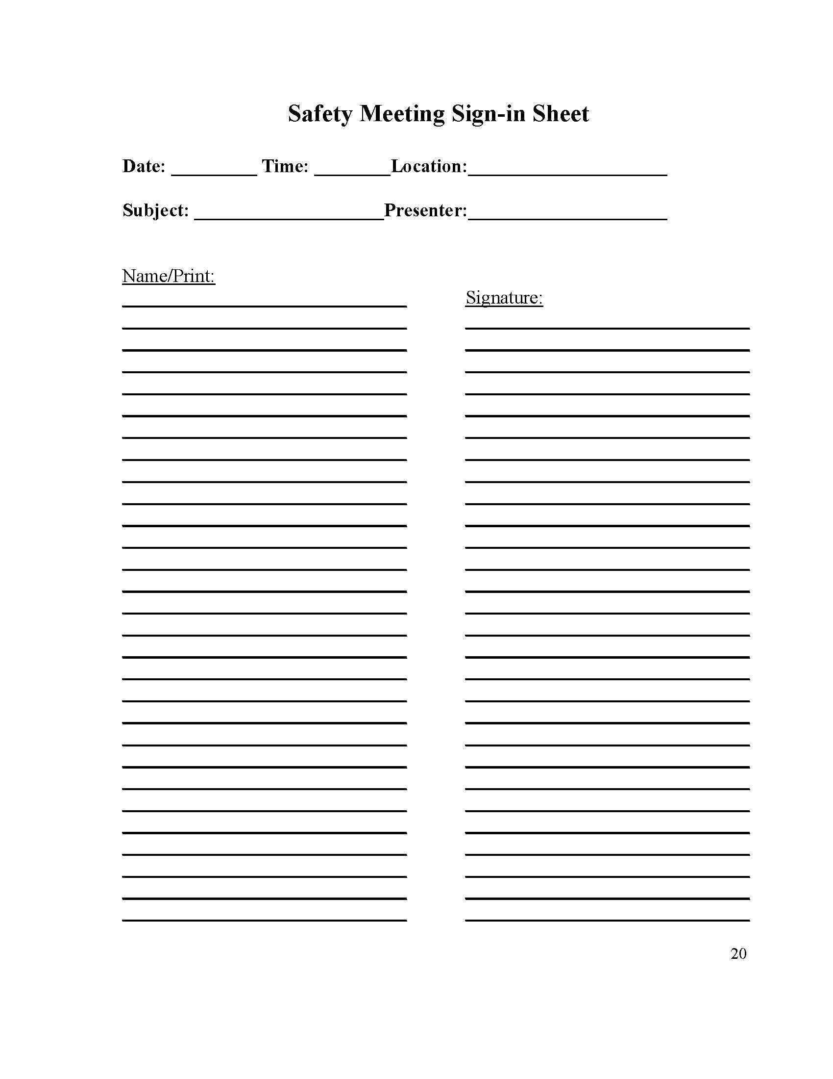
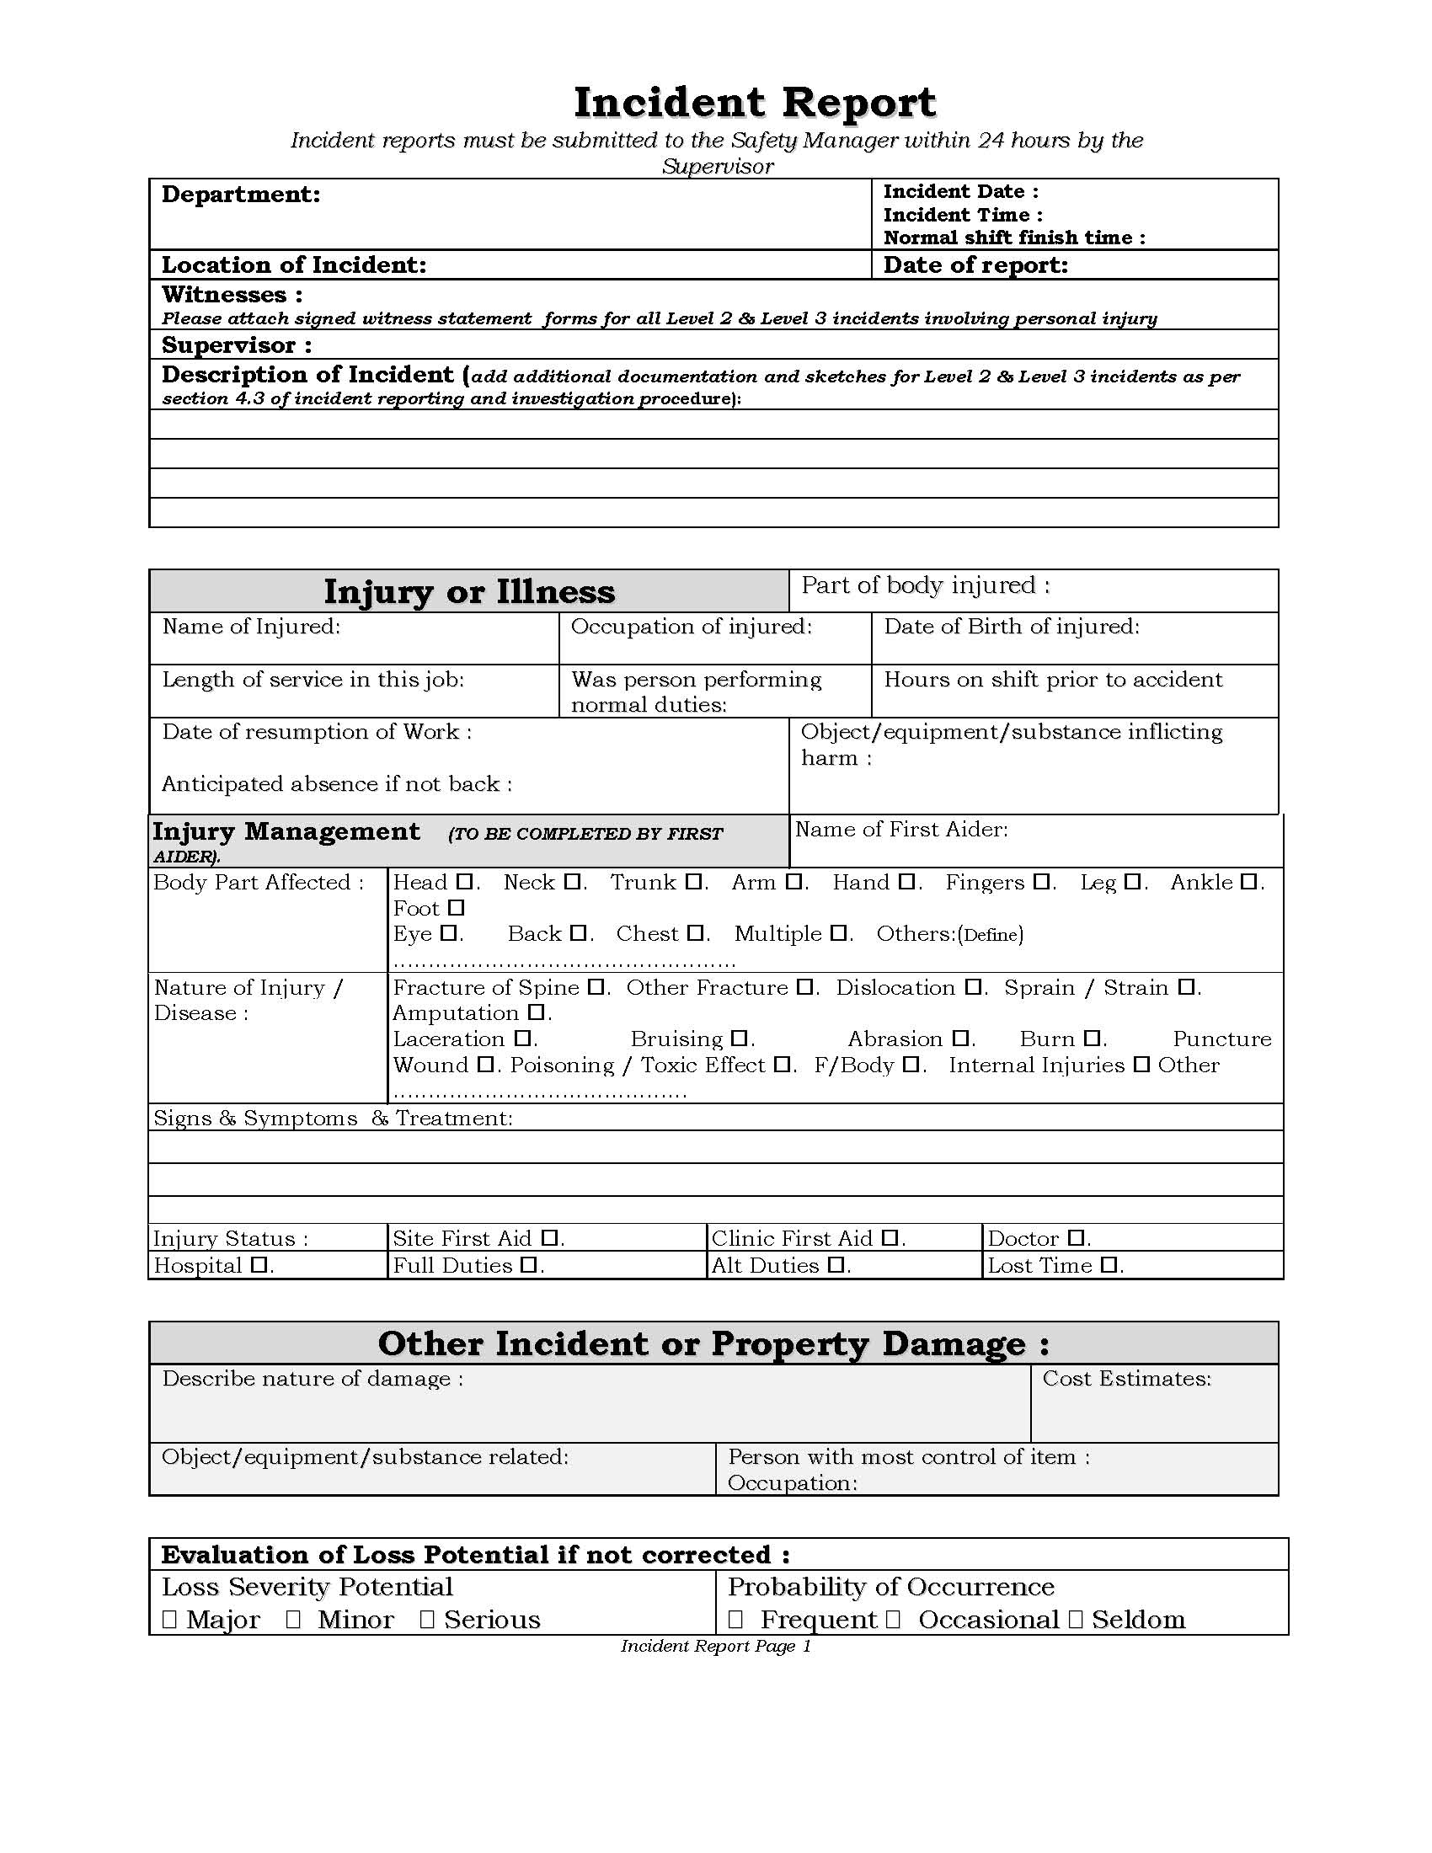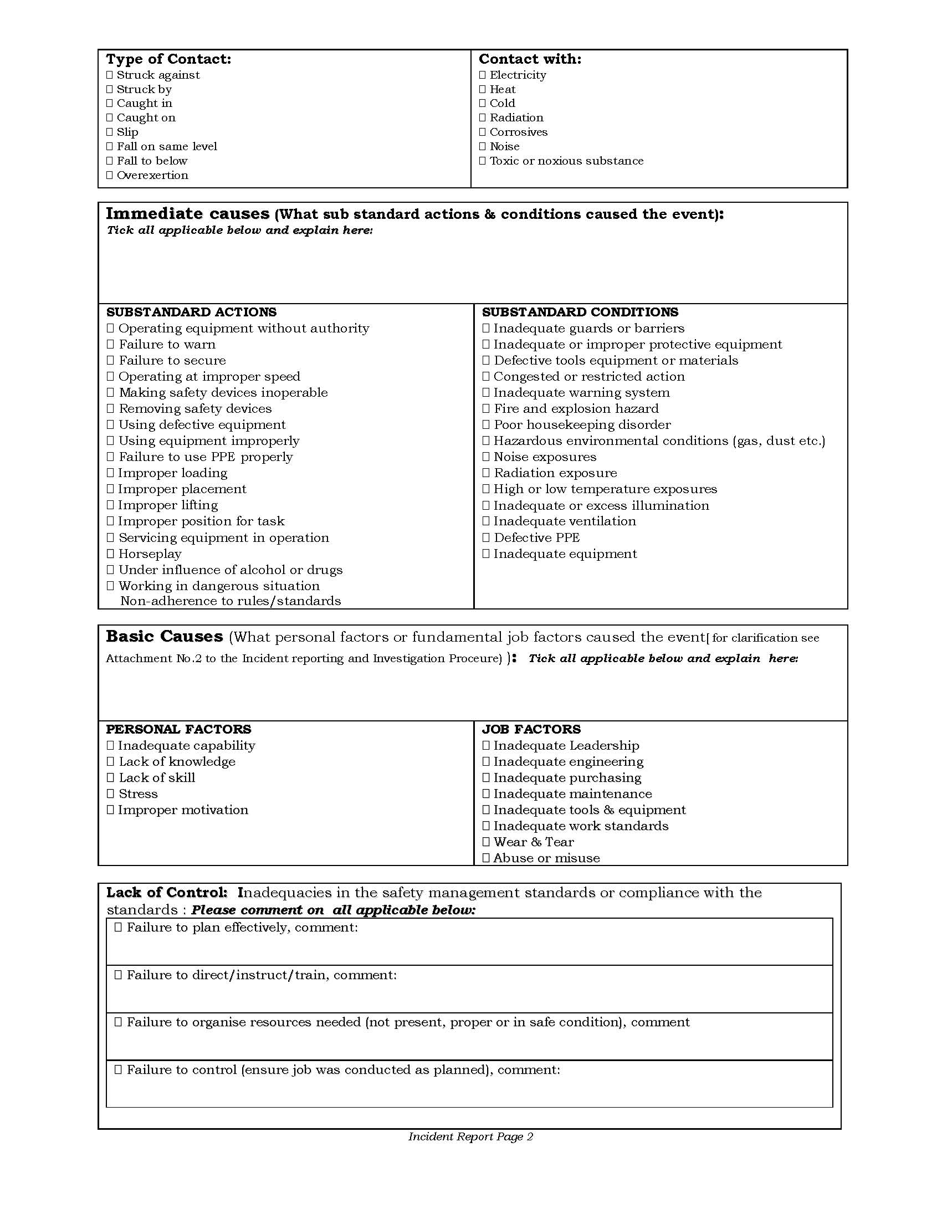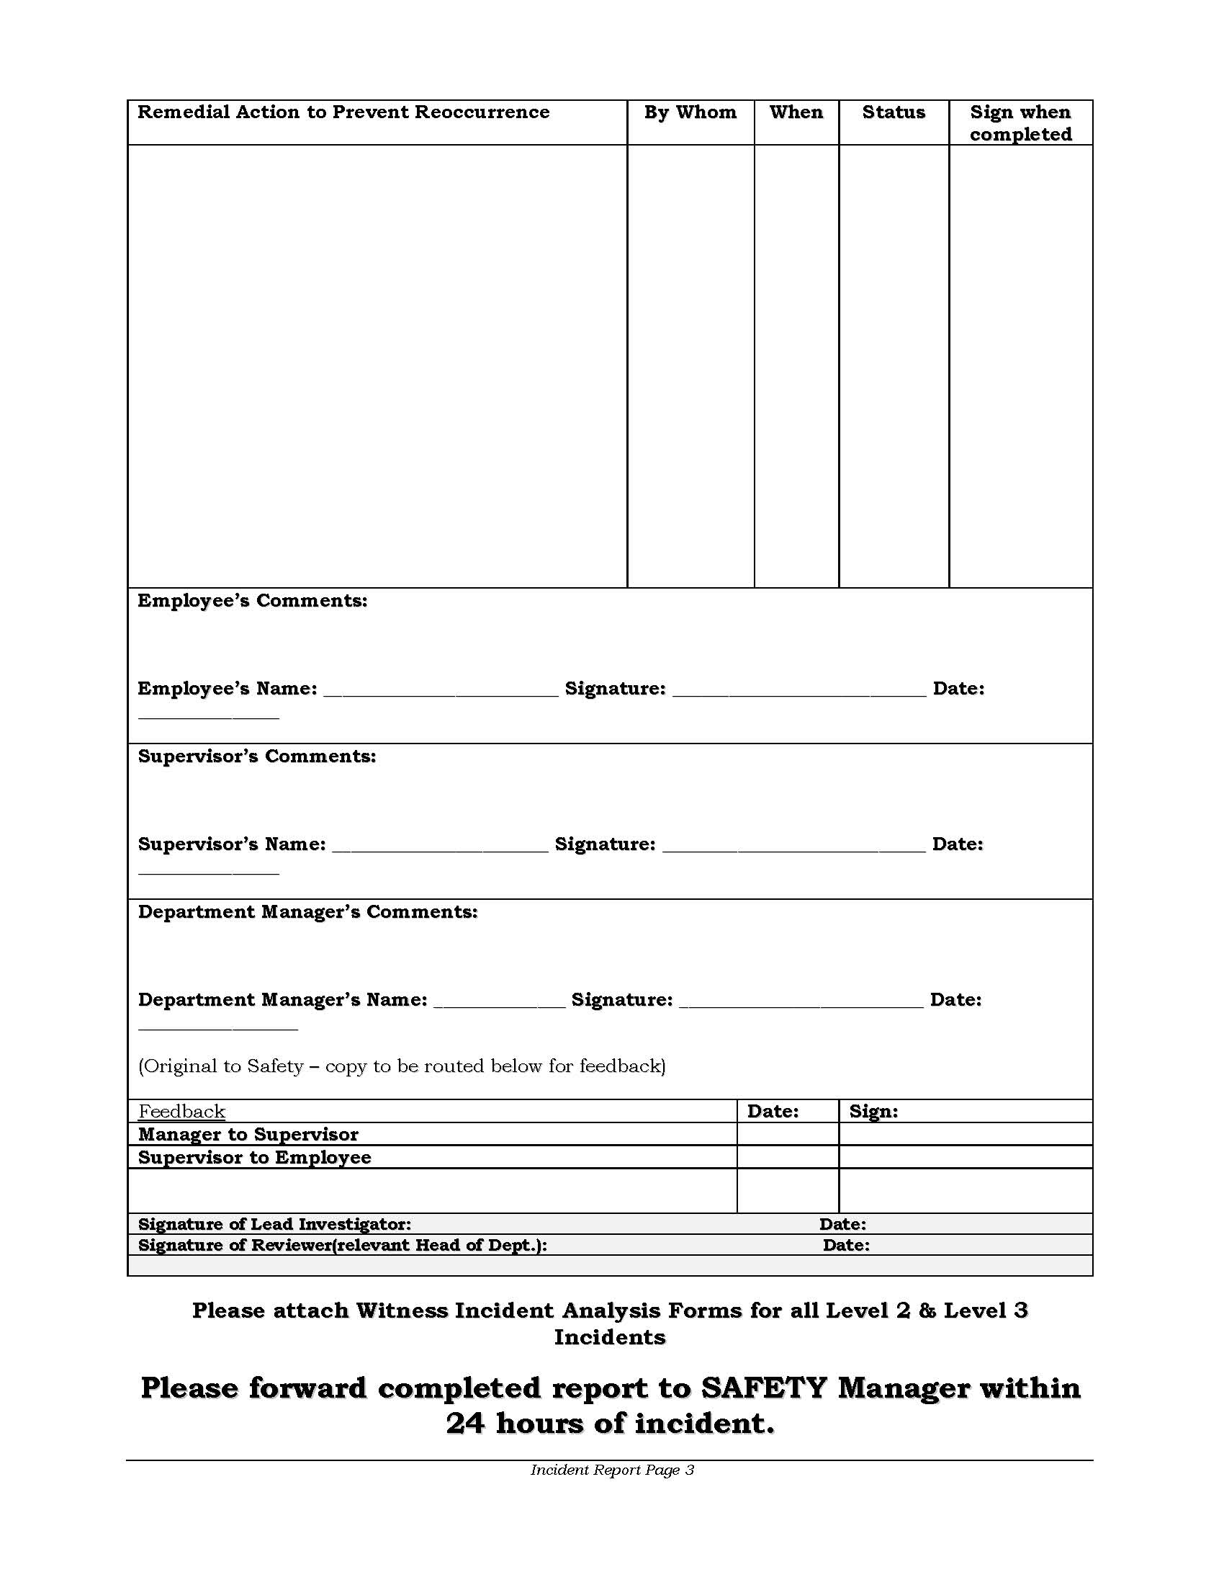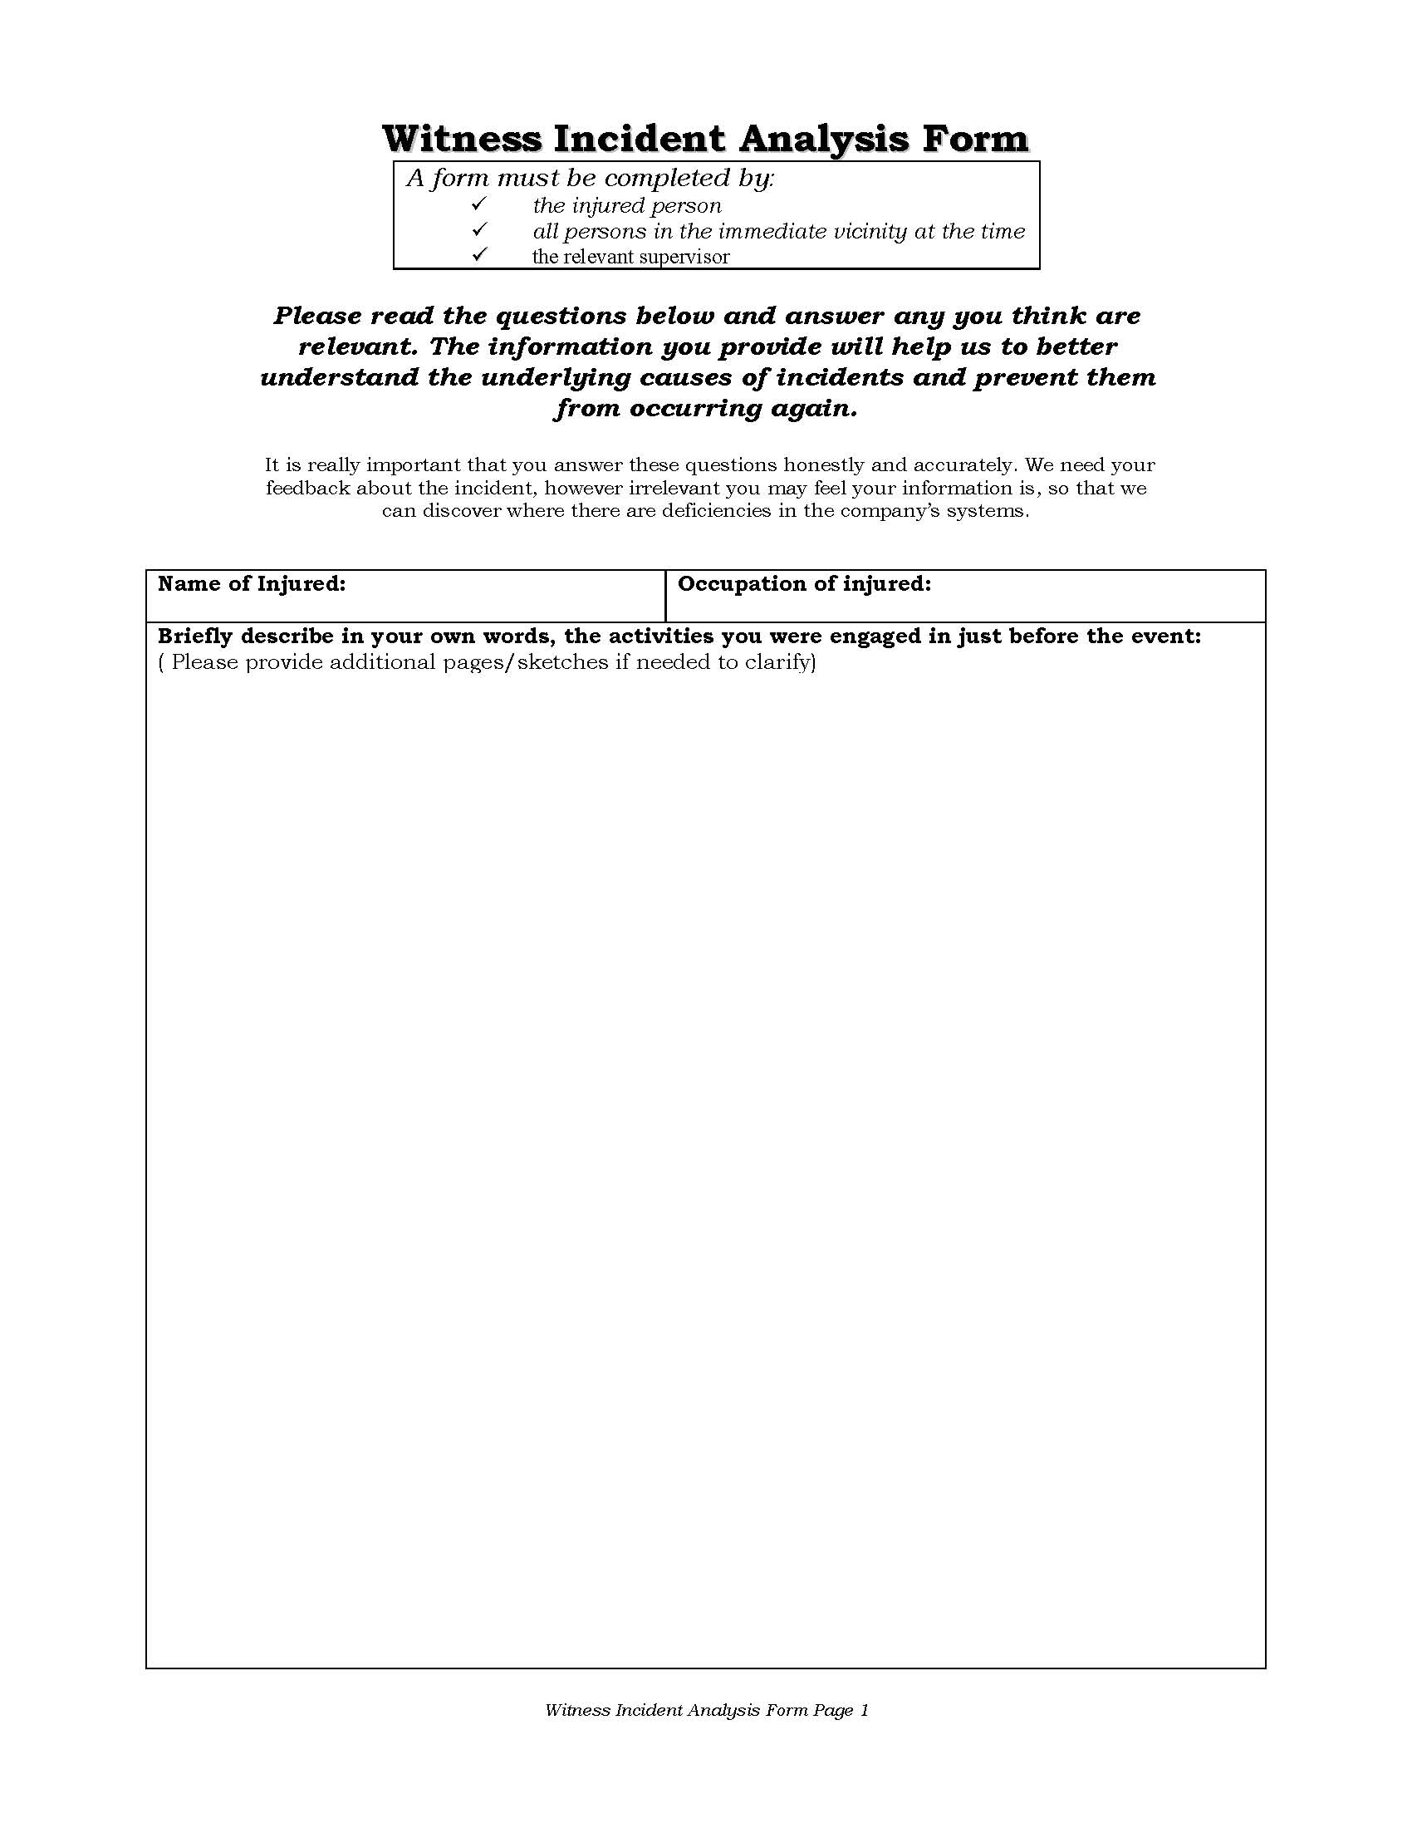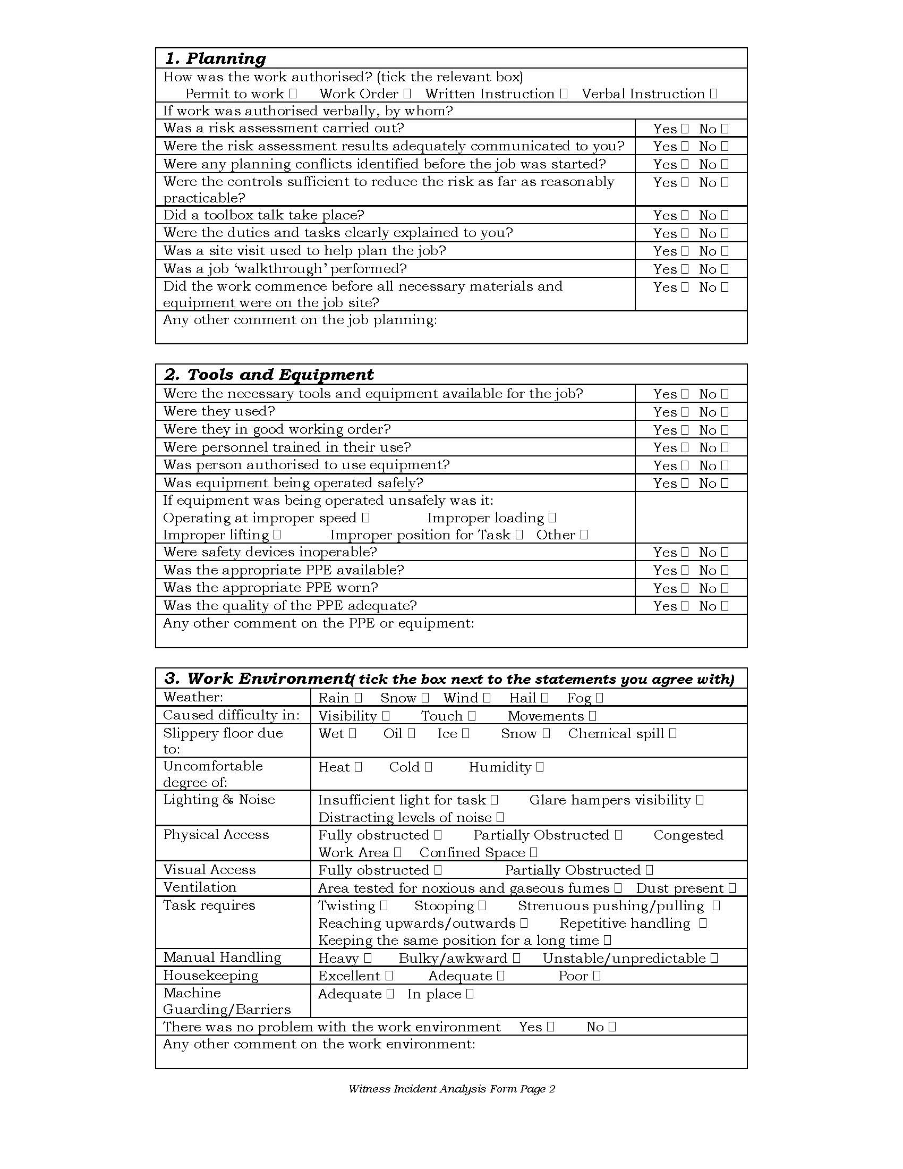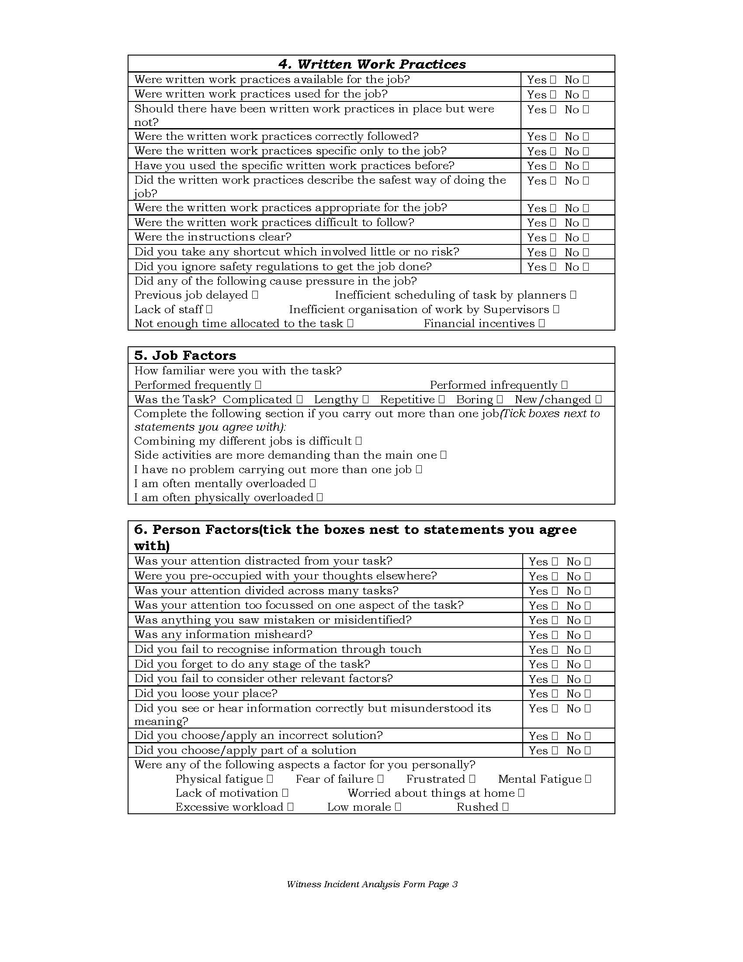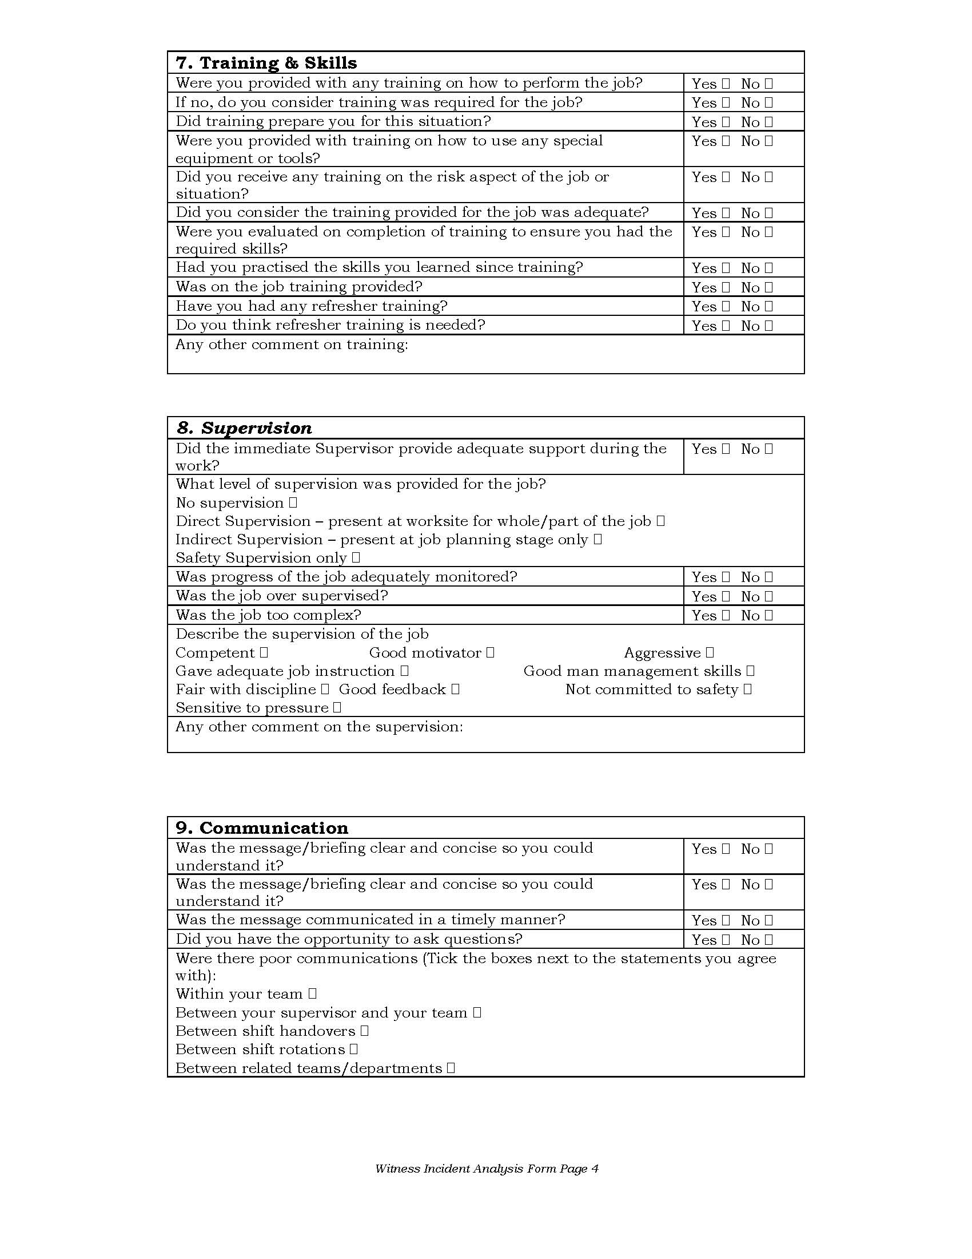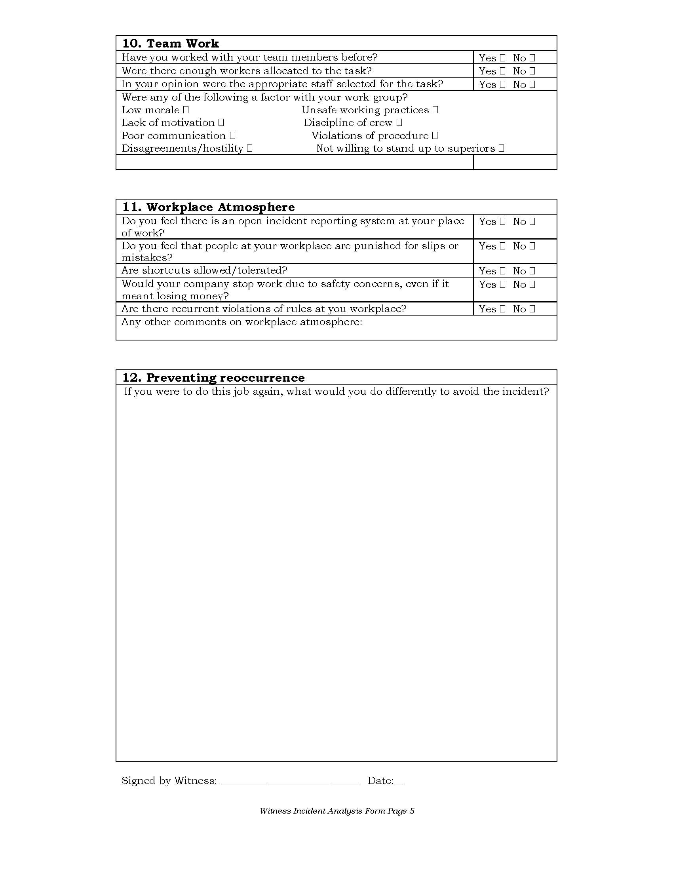

Project Personnel Resumes & Qualifications

Project resumes & qualifications shall be submitted upon request.

